**Ex.No. 9 Date :**

**CASE STUDY: POINT -OF -SALE TERMINAL**

a)Aim:develop usecase packages

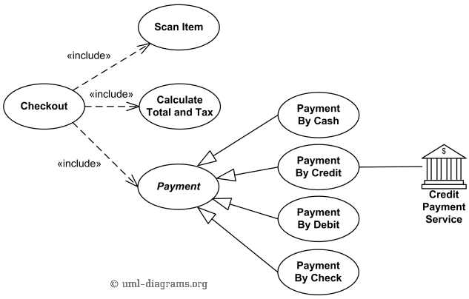

**b) Aim:** Component Diagrams

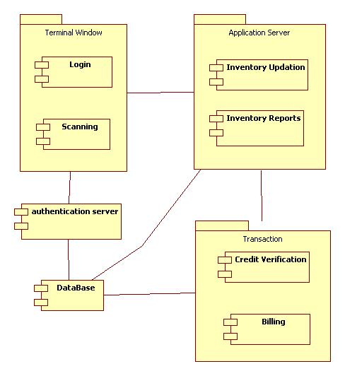

c)**Aim:** Identify relationships between usecases and represent them

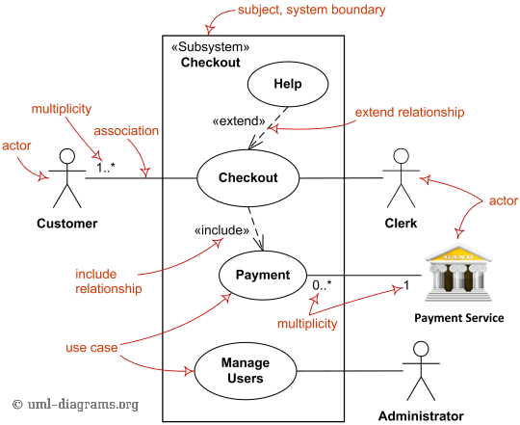

**d) Aim:** Refine domain class model by showing all the associations among classes for point of sale

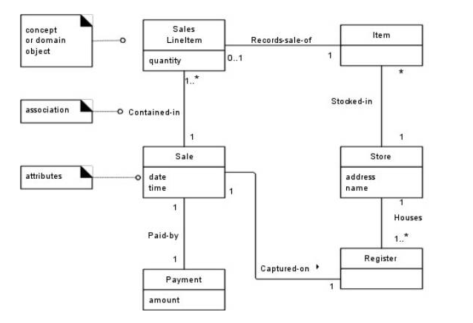

**Result:** The Design was successfully completed.